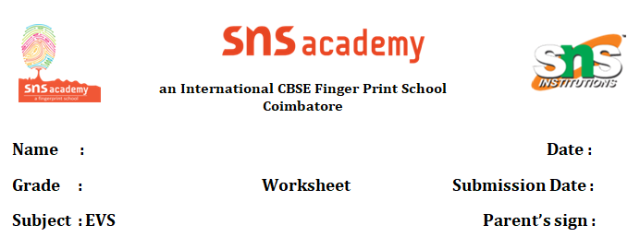
Hindi Annual Plan 2024 -25
Grade l
S.No | Month | Topic
1. | June | Swar Song (अ-ऋLetter), Swar song (a,aa,e,ee) Rhyme- Aaoo Gayee pg.no.44
2. | July | Swar Letter (ऋ-अ:)Swar song A se anaar a a a anaar .Vyanjan Letters (क-ड.) , Haste Bachee
3. | August | Swar Letter(च-ञ )  बादल आया pg.no.46,52
4. | September | Vyanjan Letter (ट-ण)  Colouring  Activity pg.47,52
5. | October | Vyanjan Letter (त-न)  शरीर के अंग,फ़ूल pg.no.50,51
6. | November | Vyanjan Letter (प से म ) Rhymes- आओ दोहराएँ  गिनती
7. | December | Vyanjan Letter (य-श्र )  सप्ताह के दिन pg.no-56
8. | January | Vyanjan Letter (क-श्र )  आओ कहानी बुने pg.no. 43
9. | February | Vyanjan Letter (क-श्र ) – Revision of all Rhymes
10. | March | Vyanjan Letter (क-श्र ) Revision and exam

